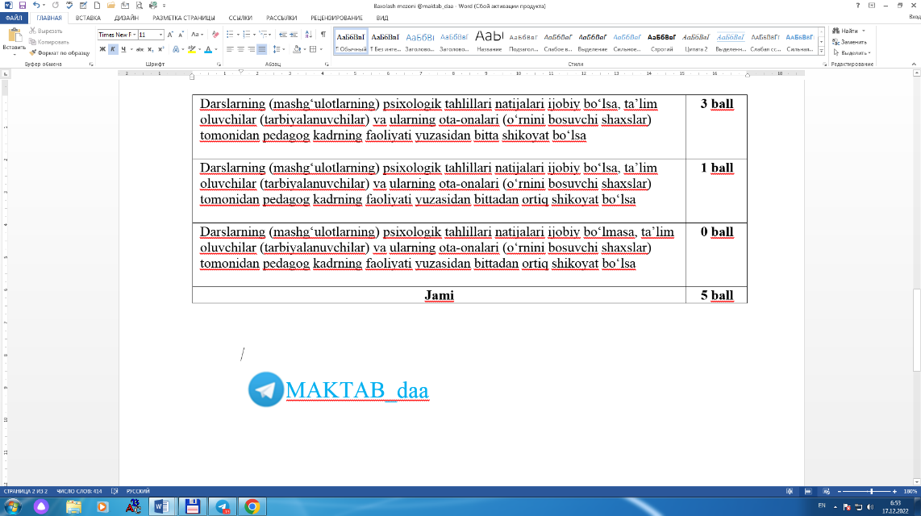Maktabgacha, umumiy o‘rta, o‘rta maxsus, professional va maktabdan tashqari ta’lim tashkilotlari pedagog kadrlarini attestatsiyadan o‘tkazish tartibi to‘g‘risidagi [nizomga](-http://cli.lex.uz/ld/lps/doc/5641270#-5646551)  
6-ILOVA

|  |  |  |  |  |  |  |  |  |  |  |  |  |  |  |  |  |  |  |  |
| --- | --- | --- | --- | --- | --- | --- | --- | --- | --- | --- | --- | --- | --- | --- | --- | --- | --- | --- | --- |
|  |  |  |  |  |  |  |  |  |  |  |  |  |  |  |  |  |  |  |  |
| **Pedagog kadrning pedagogik mahorati va psixologik tayyorgarligini baholash natijalari yuzasidan MA’LUMOTNOMA** | | | | | | | | | | | | | | | | | | | |
| ________________________________________________________________________ | | | | | | | | | | | | | | | | | | | |
| (respublika, viloyat, tuman (shahar) nomi) | | | | | | | | | | | | | | | | | | | |
| _________________________________ __________________________ fani o‘qituvchisi | | | | | | | | | | | | | | | | | | | |
| (ta’lim tashkilotining nomi va raqami) | | | | | | | | | (fan nomi) | | | | | | |  |  |  |  |
| ________________________________ning pedagogik mahorati va psixologik tayyorgarligi | | | | | | | | | | | | | | | | | | | |
|  | (pedagog kadrning F.I.O.) | | | | | | |  |  |  |  |  |  |  |  |  |  |  |  |
| ________________________________________________________ ball bilan baholandi. | | | | | | | | | | | | | | | | | | | |
| (to‘plangan ball raqam va so‘z bilan) | | | | | | | | | | | | | | | |  |  |  |  |
| Mazkur ma’lumotnoma 20_____ yil ______ __________________________________dagi | | | | | | | | | | | | | | | | | | | |
| ________________________ raqamli sertifikat asosida ___________________________ | | | | | | | | | | | | | | | | | | | |
| (sertifikat seriyasi va raqami) | | | | | | |  |  |  |  |  | (malaka toifasi (lavozimi) nomi) | | | | | | | |
| malaka toifasiga (lavozimiga) ega pedagog kadrga 20___ yil ___ _______________ oylarida o‘tkaziladigan _____________________________ attestatsiyada ishtirok etish uchun berildi. | | | | | | | | | | | | | | | | | | | |
|  |  |  | (attestatsiya turi) | | | | | | | |  |  |  |  |  |  |  |  |  |
| Pedagog kadr 20____ yil ____ ____________da navbatdagi majburiy attestatsiyadan o‘tkazilgan. | | | | | | | | | | | | | | | | | | | |
| Asos: ___________________________________________________________________ | | | | | | | | | | | | | | | | | | | |
|  |  | (pedagogik (kuzatuv) kengashining qarori yoki jalb qilingan | | | | | | | | | | | | | | | | | |
| ____________________________________________ tashkilot (mutaxassisning) xulosasi) | | | | | | | | | | | | | | | | | | | |
|  |  |  |  |  |  |  |  |  |  |  |  |  |  |  |  |  |  |  |  |
| Ta’lim tashkiloti rahbari: | | | | | |  | __________ | | |  |  | __________________ | | | | | |  |  |
|  |  |  |  |  |  |  | (imzo) | | |  |  | (rahbarning F.I.O.) | | | | | |  |  |
| M.O‘. | |  |  |  |  |  |  |  |  |  |  |  |  |  |  |  |  |  |  |
| Ro‘yxatdan o‘tkazish raqami: _____________________________ | | | | | | | | | | | | | | | | | | | |
| Berilgan sanasi: _______________________________________ | | | | | | | | | | | | | | | | | | | |
|  |  |  |  | (kun, oy, yil) | | | | | | | | | |  |  |  |  |  |  |