1-savol:An Active learner learns _______ and share the process of learning with others
A)collaborate
B)high results
C) learning style
D)focusing on
2-savol:What was invented Steve Jobs?
A) car
B) computer
C)refregirator
D)light bulb
3-savol:Match the defenitions. lack of success
A) inventor
B)successful
C) failure
D)assistant
4-savol:Match the definitions. A student
A)assistant
B)genius
C)teacher
D)sales
5-savol:Using the infinitive forms.It is important_________ information ________results in the project
A)to organise, to have
B)to have, to get
C)to go, to chat
D)to get, to have
6-savol:Match the definition.A person who sells wood
A) update
B)woodcutter
C)salary
D) timber merchant
7-savol:Answer the questions.Why we use dictionary?
A) to take photographs
B) to look up the word
C)to listen to the news
D)to make better writing
8-savol:Complete the sentences.In Uzbekistan, 11 years of education is _______ and free.
A)compulsory
B)consult
C)contribute
D)collaborate
9-savol:”Accident is the name of the greatest of all inventors” Who is author of these words?
A)George Land
B)Henry
C)W.Shekspear
D) Mark Twain
10-savol:Answer the question?Who is Truong Son?
A) karate championship
B)chess championship
C)football player
D)musican
11-savol:Label the picture. 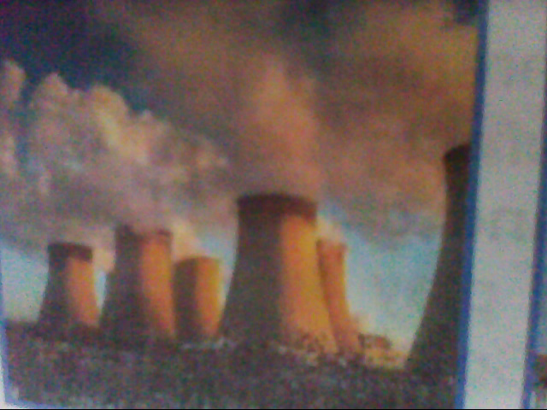WW
A)air pollution
B)water pollution
C)land pollution
D)noise pollution
12-savol:____________ all the living things in area and the way they affect each other and the environment
A) climate
B)atmosphere
C) ecosystem
D)global warming
13-savol:The word extinct means ……
A) to become endangered
B)to become rare
C)in need of protection
D) something that has died and no longer exists
14-savol:Who is Yusuf Kamalov?
A)scientist
B)reporter
C)fisherman
D)singer
15-savol:What rivers flow into the Aral Sea?
A)Amu darya and Syr darya
B)Zarafshan and Syr darya
C)Norin and Syr darya
D)Amu darya and Chirchiq
16-savol:A chess player of highest class
A)great ability
B)grand master
C) earn money
D)take part
17-savol:You can find ____ on cigarette packages in many countries
A)die
B)cough
C)warning
D)breathe
18-savol:A doctor who specializes in bones__________
19-savol:Found in meat,fish and eggs ___________
20-savol:Part of the food that works quickly but might not be very good_________
21-savol:What is calcium? _________
22-savol:________ are the main part of the entertainment of Nurota Camp
23-savol:To “feel out” means_______
24-savol:A flat hat made of felt worn by school girls and French men.____________
25-savol:A bulb like vegetable with strong smell and flavor and unpleasant taste is_____

1 | 2 | 3 | 4 | 5 | 6 | 7 | 8 | 9 | 10 | 11 | 12 | 13 | 14 | 15 | 16 | 17

18.Orthopedic Doctor
19.protein
20.quick-fix
21.a mineral needed for strong bones and teeth
22.Camels
23.test and idea
24.beret
25.garlic

