[](https://www.google.co.uz/imgres?imgurl=http%3A%2F%2Foqituvchi.uz%2Fnewsknigi%2Faugust%2Fyer_sayyorasi.jpg&imgrefurl=http%3A%2F%2Foqituvchi.uz%2Fview_newsknigi.php%3Fnews%3D14&docid=TmeOtQOd4SAjbM&tbnid=0suTd4hIQXaJgM%3A&vet=1&w=250&h=318&bih=947&biw=1920&q=zahiriddin%20muhammad%20bobur%20kitoblar%20foto&ved=0ahUKEwjwm-npjrfRAhVedVAKHcBEDdYQMwg4KBQwFA&iact=mrc&uact=8)

[](https://www.google.co.uz/imgres?imgurl=http%3A%2F%2Fkitob-1dimi.uz%2Fwp-content%2Fuploads%2F2016%2F04%2FDarslogo.jpg&imgrefurl=http%3A%2F%2Fkitob-1dimi.uz%2Fdate%2F2016%2F02%2F&docid=aVS-JVFhBU-CXM&tbnid=Bad5xPavLqylYM%3A&vet=1&w=251&h=220&bih=947&biw=1920&q=zahiriddin%20muhammad%20bobur%20kitoblar%20foto&ved=0ahUKEwjwm-npjrfRAhVedVAKHcBEDdYQMwg5KBUwFQ&iact=mrc&uact=8)

[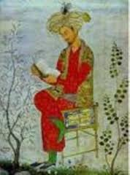](https://www.google.co.uz/imgres?imgurl=http%3A%2F%2Ftaqvim.uz%2F%2Fuploads%2Flibrary%2Fphotos%2F8a93ff99b4a5c470e088590171e5d23f.jpg&imgrefurl=http%3A%2F%2Ftaqvim.uz%2Fru%2Flibrary%2Fview%2F170&docid=h31tt9MtArU6UM&tbnid=80dy5k8tPjzxsM%3A&vet=1&w=223&h=300&bih=947&biw=1920&q=zahiriddin%20muhammad%20bobur%20kitoblar%20foto&ved=0ahUKEwjwm-npjrfRAhVedVAKHcBEDdYQMwg6KBYwFg&iact=mrc&uact=8)

[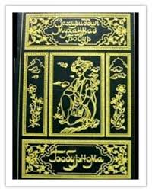](https://www.google.co.uz/imgres?imgurl=http%3A%2F%2Fphotoload.ru%2Fdata%2Fa3%2Fc6%2F1f%2Fa3c61f2c851100a1e813691f72cd7472.jpg&imgrefurl=http%3A%2F%2Fkh-davron.uz%2Ftag%2Fboburnoma&docid=UuZMLPbq-tAT8M&tbnid=REiNpZ2vsz7mfM%3A&vet=1&w=336&h=423&bih=947&biw=1920&q=zahiriddin%20muhammad%20bobur%20kitoblar%20foto&ved=0ahUKEwjwm-npjrfRAhVedVAKHcBEDdYQMwg7KBcwFw&iact=mrc&uact=8)

[](https://www.google.co.uz/imgres?imgurl=http%3A%2F%2Fziyonet.uz%2Fuploads%2Faudiobooks%2F555273%2F56bde8c28d7df.jpg&imgrefurl=http%3A%2F%2Fziyonet.uz%2Fuz%2Fsite%2Fsearch%3FFind%255Bsearch_value%255D%3Dbobur%26Find%255Bresource%255D%3Deverywhere&docid=QOC-SNbK7W3EDM&tbnid=XBw2q8fuIG2MNM%3A&vet=1&w=201&h=201&bih=947&biw=1920&q=zahiriddin%20muhammad%20bobur%20kitoblar%20foto&ved=0ahUKEwjwm-npjrfRAhVedVAKHcBEDdYQMwg8KBgwGA&iact=mrc&uact=8)

[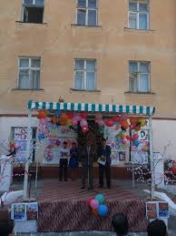](https://www.google.co.uz/imgres?imgurl=http%3A%2F%2Ftdpu.uz%2Fupload%2F2759_7075.jpg&imgrefurl=http%3A%2F%2Fwww.tdpu.uz%2F2759.html%2Fen&docid=FtcGdKm70KZovM&tbnid=WBFNM7cLZFvHcM%3A&vet=1&w=640&h=853&bih=947&biw=1920&q=zahiriddin%20muhammad%20bobur%20kitoblar%20foto&ved=0ahUKEwjwm-npjrfRAhVedVAKHcBEDdYQMwg9KBkwGQ&iact=mrc&uact=8)

[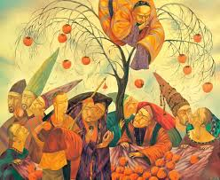](https://www.google.co.uz/imgres?imgurl=http%3A%2F%2Fziyonet.uz%2Fuploads%2Fwonder%2F5534e5877f424.jpg&imgrefurl=http%3A%2F%2Fziyonet.uz%2Fuz%2Fsite%2Fsearch%3FFind%255Bsearch_value%255D%3Dbobur%26Find%255Bresource%255D%3Deverywhere&docid=QOC-SNbK7W3EDM&tbnid=ZG3SxU8x3dklQM%3A&vet=1&w=800&h=655&bih=947&biw=1920&q=zahiriddin%20muhammad%20bobur%20kitoblar%20foto&ved=0ahUKEwjwm-npjrfRAhVedVAKHcBEDdYQMwg-KBowGg&iact=mrc&uact=8)

[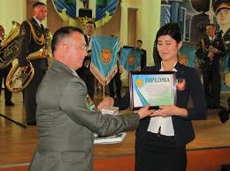](https://www.google.co.uz/imgres?imgurl=http%3A%2F%2Ftdpu.uz%2Fupload%2F2663_6561.jpg&imgrefurl=http%3A%2F%2Fwww.tdpu.uz%2F2663.html&docid=93ig2E75RGhcMM&tbnid=DgcXYLNybpbFgM%3A&vet=1&w=640&h=478&bih=947&biw=1920&q=zahiriddin%20muhammad%20bobur%20kitoblar%20foto&ved=0ahUKEwjwm-npjrfRAhVedVAKHcBEDdYQMwg_KBswGw&iact=mrc&uact=8)

[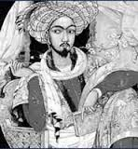](https://www.google.co.uz/imgres?imgurl=http%3A%2F%2Fziyouz.com%2Frasmlar%2Fpoems%2Fbobur.jpg&imgrefurl=http%3A%2F%2Fkh-davron.uz%2Fmultimedia%2Fbobur-maqom-oqshomi.html&docid=3TV5znilxKQZ-M&tbnid=5A_iQGzwRq0tEM%3A&vet=1&w=185&h=200&bih=947&biw=1920&q=zahiriddin%20muhammad%20bobur%20kitoblar%20foto&ved=0ahUKEwjwm-npjrfRAhVedVAKHcBEDdYQMwhAKBwwHA&iact=mrc&uact=8)

[](https://www.google.co.uz/imgres?imgurl=http%3A%2F%2Fziyonet.uz%2Fuploads%2Faudiobooks%2F29429%2F56cc3b390201f.jpg&imgrefurl=http%3A%2F%2Fziyonet.uz%2Fuz%2Fsite%2Fsearch%3FFind%255Bsearch_value%255D%3Dbobur%26Find%255Bresource%255D%3Deverywhere&docid=QOC-SNbK7W3EDM&tbnid=HV6zf8xvgxrgVM%3A&vet=1&w=201&h=201&bih=947&biw=1920&q=zahiriddin%20muhammad%20bobur%20kitoblar%20foto&ved=0ahUKEwjwm-npjrfRAhVedVAKHcBEDdYQMwhBKB0wHQ&iact=mrc&uact=8)

[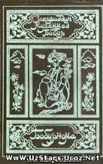](https://www.google.co.uz/imgres?imgurl=http%3A%2F%2Fuzstars.ucoz.net%2F_nw%2F1%2F93199766.jpg&imgrefurl=http%3A%2F%2Fuzstars.ucoz.net%2Fnews%2F1%2F2013-01-22-173&docid=ou0QUKZpRmlTvM&tbnid=LQYBo6TlDEWFBM%3A&vet=1&w=168&h=265&bih=947&biw=1920&q=zahiriddin%20muhammad%20bobur%20kitoblar%20foto&ved=0ahUKEwjwm-npjrfRAhVedVAKHcBEDdYQMwhCKB4wHg&iact=mrc&uact=8)

[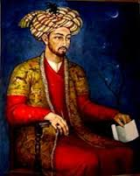](https://www.google.co.uz/imgres?imgurl=http%3A%2F%2Fwww.infocenter.uz%2Fsites%2Fdefault%2Ffiles%2F2013%2FKZD%2Fbobur.jpg&imgrefurl=http%3A%2F%2Fwww.infocenter.uz%2Fuz_kiril%2Fcontent%2F2013-yilgi-mukhim-sanalar&docid=BHcY3snywe0VtM&tbnid=SxpnDRMA4W3feM%3A&vet=1&w=200&h=252&bih=947&biw=1920&q=zahiriddin%20muhammad%20bobur%20kitoblar%20foto&ved=0ahUKEwjwm-npjrfRAhVedVAKHcBEDdYQMwhDKB8wHw&iact=mrc&uact=8)

[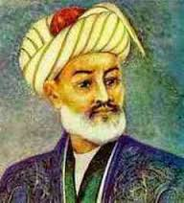](https://www.google.co.uz/imgres?imgurl=http%3A%2F%2Fkitob-1dimi.uz%2Fwp-content%2Fuploads%2F2016%2F02%2F201602120926181.jpg&imgrefurl=http%3A%2F%2Fkitob-1dimi.uz%2Fdate%2F2016%2F02%2F&docid=aVS-JVFhBU-CXM&tbnid=2Fqp1c0jaW_UwM%3A&vet=1&w=240&h=266&bih=947&biw=1920&q=zahiriddin%20muhammad%20bobur%20kitoblar%20foto&ved=0ahUKEwjwm-npjrfRAhVedVAKHcBEDdYQMwhEKCAwIA&iact=mrc&uact=8)

[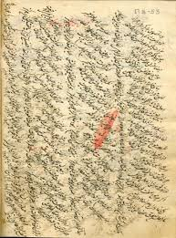](https://www.google.co.uz/imgres?imgurl=http%3A%2F%2Fold.natlib.uz%3A8101%2Fwww_data%2Farticles%2Ff6%2819%29.jpg&imgrefurl=http%3A%2F%2Fold.natlib.uz%3A8101%2Fuz%2Farticle%2F1386%2F&docid=j5RDXpHhzE2QZM&tbnid=b0OPnR55Cvj1XM%3A&vet=1&w=436&h=587&bih=947&biw=1920&q=zahiriddin%20muhammad%20bobur%20kitoblar%20foto&ved=0ahUKEwjwm-npjrfRAhVedVAKHcBEDdYQMwhFKCEwIQ&iact=mrc&uact=8)

[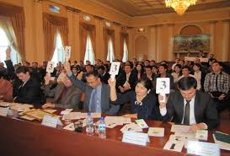](https://www.google.co.uz/imgres?imgurl=http%3A%2F%2Ftdpu.uz%2Fupload%2F2663_6564.jpg&imgrefurl=http%3A%2F%2Fwww.tdpu.uz%2F2663.html&docid=93ig2E75RGhcMM&tbnid=fzZCCnAYyCyECM%3A&vet=1&w=640&h=433&bih=947&biw=1920&q=zahiriddin%20muhammad%20bobur%20kitoblar%20foto&ved=0ahUKEwjwm-npjrfRAhVedVAKHcBEDdYQMwhGKCIwIg&iact=mrc&uact=8)

[](https://www.google.co.uz/imgres?imgurl=http%3A%2F%2Fwww.api.uz%2Fimg%2Fnews%2Fphoto%2F000000003765.jpg&imgrefurl=http%3A%2F%2Fwww.api.uz%2Fnews%2Finfo%2Fpolygraph%2F3765%2F&docid=NWPcw3guWLTIOM&tbnid=Nm5_0Uky2FDZ3M%3A&vet=1&w=480&h=320&bih=947&biw=1920&q=zahiriddin%20muhammad%20bobur%20kitoblar%20foto&ved=0ahUKEwjwm-npjrfRAhVedVAKHcBEDdYQMwhHKCMwIw&iact=mrc&uact=8)

[](https://www.google.co.uz/imgres?imgurl=http%3A%2F%2Fziyonet.uz%2Fuploads%2Faudiobooks%2F29429%2F56cc38349afb3.jpg&imgrefurl=http%3A%2F%2Fziyonet.uz%2Fuz%2Fsite%2Fsearch%3FFind%255Bsearch_value%255D%3Dbobur%26Find%255Bresource%255D%3Deverywhere&docid=QOC-SNbK7W3EDM&tbnid=rkw5iexmBWB_wM%3A&vet=1&w=201&h=201&bih=947&biw=1920&q=zahiriddin%20muhammad%20bobur%20kitoblar%20foto&ved=0ahUKEwjwm-npjrfRAhVedVAKHcBEDdYQMwhIKCQwJA&iact=mrc&uact=8)

[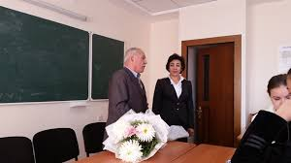](https://www.google.co.uz/imgres?imgurl=http%3A%2F%2Ftdpu.uz%2Fupload%2F3175_9277.jpg&imgrefurl=http%3A%2F%2Fwww.tdpu.uz%2F3175.html&docid=5Zur-FyM2VHKvM&tbnid=1tZCmU7frPR3ZM%3A&vet=1&w=640&h=360&itg=1&bih=947&biw=1920&q=zahiriddin%20muhammad%20bobur%20kitoblar%20foto&ved=0ahUKEwjwm-npjrfRAhVedVAKHcBEDdYQMwhJKCUwJQ&iact=mrc&uact=8)

[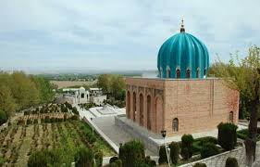](https://www.google.co.uz/imgres?imgurl=http%3A%2F%2Fziyonet.uz%2Fuploads%2Fwonder%2F55373f49acaef.jpg&imgrefurl=http%3A%2F%2Fziyonet.uz%2Fuz%2Fsite%2Fsearch%3FFind%255Bsearch_value%255D%3Dbobur%26Find%255Bresource%255D%3Deverywhere&docid=QOC-SNbK7W3EDM&tbnid=5mT3yyJjV8JlDM%3A&vet=1&w=500&h=320&bih=947&biw=1920&q=zahiriddin%20muhammad%20bobur%20kitoblar%20foto&ved=0ahUKEwjwm-npjrfRAhVedVAKHcBEDdYQMwhKKCYwJg&iact=mrc&uact=8)

[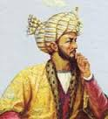](https://www.google.co.uz/imgres?imgurl=http%3A%2F%2Fziyonet.uz%2Fuploads%2Fperson%2Fperson%2F54e6c1dab41f3.jpg&imgrefurl=http%3A%2F%2Fziyonet.uz%2Fuz%2Fsite%2Fsearch%3FFind%255Bsearch_value%255D%3Dbobur%26Find%255Bresource%255D%3Deverywhere&docid=QOC-SNbK7W3EDM&tbnid=NE_0Vn5EQzL8bM%3A&vet=1&w=155&h=170&bih=947&biw=1920&q=zahiriddin%20muhammad%20bobur%20kitoblar%20foto&ved=0ahUKEwjwm-npjrfRAhVedVAKHcBEDdYQMwhLKCcwJw&iact=mrc&uact=8)

[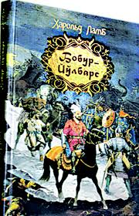](https://www.google.co.uz/imgres?imgurl=http%3A%2F%2Fguncha.uz%2Fupload%2Fimage%2F3bet.jpg&imgrefurl=http%3A%2F%2Fguncha.uz%2Fuz%2Fnews%2F9&docid=WTSSRwC1T4WFQM&tbnid=A-hfJUfsnraElM%3A&vet=1&w=1218&h=1890&itg=1&bih=947&biw=1920&q=zahiriddin%20muhammad%20bobur%20kitoblar%20foto&ved=0ahUKEwjwm-npjrfRAhVedVAKHcBEDdYQMwhMKCgwKA&iact=mrc&uact=8)